

|  |
| --- |
| **MATHEMATICS DEPARTMENT**  **Year 12 Methods - Test Number 2 - 2017  Applications and Integration**  **RESOURCE RICH** |

Circle the correct

**NAME: _______________________________________________________ TEACHER : __________**

**Time Allowed : 45 minutes**

**Total Marks : 60**

* **Calculators, including CAS, are permitted in this test – No Notes.**
* **A WACE Formula sheet will be provided.**
* **For Q1 to Q10, circle the correct answer. For Q11 to Q20 place answers in the spaces provided.**

1 Given that the equation of a curve is y = 3x3 + 4x2 + 5, find the approximate increase in y as x increases from 2 to 2.03.

A 45

B 46.58

C 52

D 1.56

E 1.58

[2 marks]

2 For what values of x is the curve y = 2x3 +12x2 – 18x – 5 concave upwards?

A –3 < x < –1

B x > –2

C x > 2

D 1 < x < 3

E x < –2

[2 marks]

3 The product of two positive numbers is 72. Find the numbers such that the sum of twice one number and 4 times the other is a minimum.

A 6 and 12

B 4 and 18

C 8 and 9

D 2 and 36

E 3 and 24

[2 marks]

4 Find an approximation to the area under the curve y = x4 between x = 1 and x = 2 by using four centred rectangles.

A 0.25 × (1.254 + 1.54 + 1.754 + 24)

B 0.25 × (14 + 1.254 + 1.54 + 1.754)

C 0.125 × (1.1254 + 1.3754 + 1.6254 + 1.8754)

D 0.25 × (1.1254 + 1.3754 + 1.6254 + 1.8754)

E 0.125 × (1.254 + 1.54 + 1.754 + 24)

[2 marks]

**5**

[2 marks]

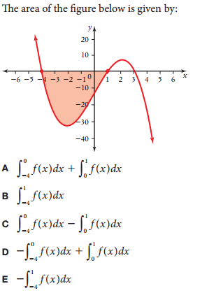

6 Simplify .

A 

B 

C 

D 

E  [2 marks]

**7**

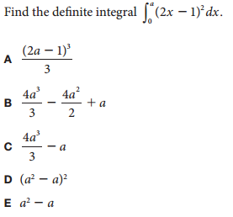

[2 marks]

**8**

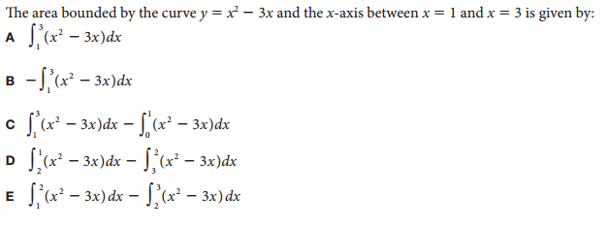

[2 marks]

9

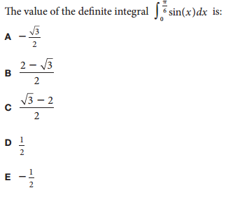

[2 marks]

10 Water flows into a container at the rate R´(t) = 10e0.2*t* (L/min) where t is in minutes. What is the total number of litres (to the nearest litre) that flowed into the container in the first 5 minutes?

A 50

B 86

C 120

D 136

E 75

[2 marks]

11 The average mark out of 50, A, for a standard entry test into a local university was studied over time, and at the start the average mark was 38.

a During the study, the first derivative of A with respect to time was less than zero. What does this say about the marks for the entry test during the study?

b If at the same time, the second derivative was less than zero what can you say about the rate of change of the average mark?

c Sketch the graph of the average A against t.

[5 marks]

12 SPC Australia manufacturers large cylindrical aluminium cans for their different brands of tinned fruit, each with a volume of 500 mL (i.e. 500 cm3). What is the radius of the can if the least amount of material is to be used in its construction? Give your answer correct to 2 significant figures.

**[6 marks]**

**13** Evaluate each of the following definite integrals:

**a**



**b**



**c**



**d**



**[8 marks]**

**14 a** Evaluate .



**b** Find the area enclosed between the curve *y* = 2*x*3 and the *x*-axis between *x* = –3 and *x* = 3.

**[6 marks]**

**15** Find *y* in terms of *x* if = 8*x* − 7 and *y* = 13 when *x* = −1.



**[3 marks]**

16 A slow-moving river is one kilometre wide. Tom wants to return to his camp on the opposite side of the river. He can swim at 2 km/h and walk at 3 km/h. Tom must first swim across the river to any point on the opposite bank then, from there, walk to his camp, which is one km from the point directly across the river from where he started his swim. What route will take the least amount of time? How long would this route take?

**[6 marks]**

**17 a** Differentiate tan(3*x*).

**b** Hence find the value of .



**[6 marks]**

**\*\*\*END OF TEST\*\*\***

Additional working space below: